* 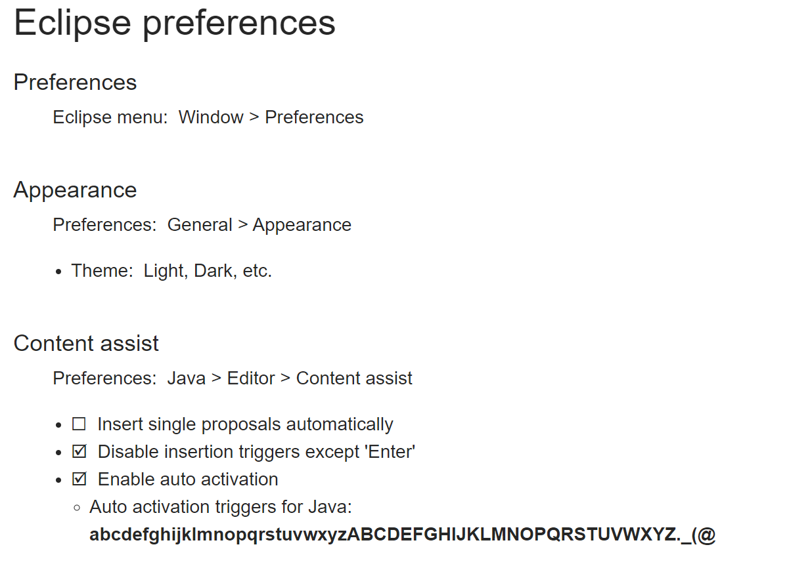
* Auto activation triggers for Java:  
  **abcdefghijklmnopqrstuvwxyzABCDEFGHIJKLMNOPQRSTUVWXYZ._(@**

Last modified: Wednesday, 10 July 2019, 7:02 PM